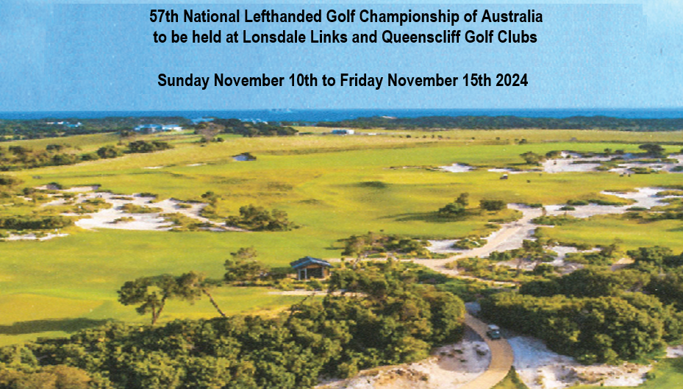
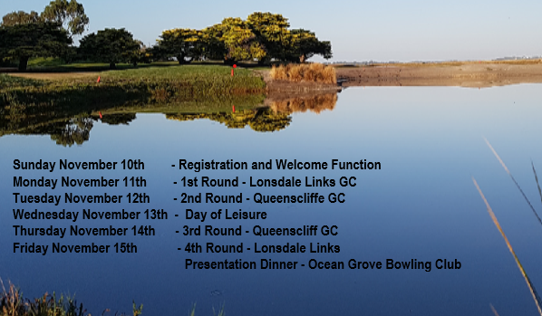

Helpful information re the Championship
Point Lonsdale and Queenscliff are located on the
Victorian Bellarine Peninsula.
Both town centres are approximately a two hour drive from Melbourne and approximately a half hour drive from Geelong, Victoria’s largest regional city

Getting to the Bellarine Peninsula, Victoria – Point Lonsdale & Queenscliff
Fly to Avalon Airport
Hire a car and approx 1 hour drive

Fly to Tullamarine Airport
Hire a car and approx 1.75 hour drive

From Tassie
Catch the Spirit of Tasmania and sail to Geelong (North Shore), then approx 40min drive

Driving
From Adelaide – approx 8.5 hours, Sydney – approx 10 hours, Brisbane – approx 20 hours

Golf Courses
Lonsdale Links Golf Club
The golf course has been redesigned since our last visit in 2014 and was ranked No 20 in Australia by Golf Australia Magazine in 2022.
Please note Lonsdale Links is a cash free zone. Purchases within the club can only be made by using Debit or Credit cards.

Queenscliff Golf Club
Queenscliff Golf Club is located on Swan Island, Queenscliff.
Swan Island is Department of Defence land.
To gain entry, at the Bridge St Gatehouse identify yourself as a golfer.
You must produce a valid Driver’s License (Digital not accepted)
Please be early to avoid missing tee time.

Helpful information re the Championship
Golf & Golf Carts
It is proposed that there will be shotgun starts on all 4 days of play
Both venues have limited carts available.
Carts will be allocated to players as per the entry form requests and paid for at the individual Club Pro Shop on each day of play.
Players with doctor certificates will get preference

Registration & Welcome Function – Lonsdale Links Golf Club
Registration from 3pm to 5pm
Welcome Function 5.30pm to 7pm – with finger food being served

Presentation Dinner – Ocean Grove Bowling Club
Ocean Grove is a 15 minute drive from Queenscliff and Point Lonsdale
Arrive at 6pm, to be seated by 6.30pm

Accommodation and Tourist Information
- Ocean Grove Holiday Park (Cabins) Contact: (03) 5256 2233
- Big Four Caravan Park Bellarine Contact : (03) 5251 5744
WEB | www.big4bellarine.com.au EMAIL | info@big4bellarine.com.au
- BIG4 Ingenia Holidays Queenscliff Beacon,
78 Bellarine Highway, Queenscliff 3225 Contact: 03 5258 1133
- Website for Queenscliff Accommodation
https://www.queenscliffvictoria.com.au/queenscliff-accommodation/

- Queenscliff Tourist Information
https://www.queenscliffe.vic.gov.au/Things-to-do/Visitor-information-centre

