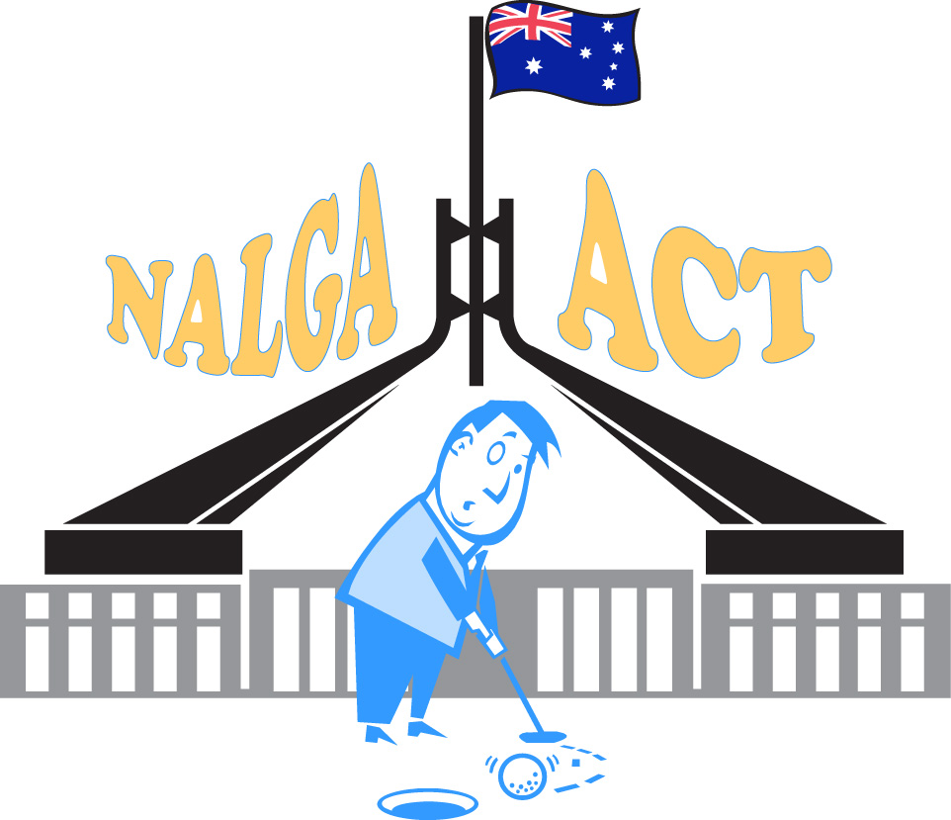
NATIONAL ASSOCIATION OF LEFT-HANDED GOLFERS OF AUSTRALIA
A.C.T DIVISION INCORPORATED

15 Metcalfe St Nicholls ACT 2913

LIFE MEMBERS: Don James

: Jim Smith

PRESIDENT: John Longmire

CAPTAIN: Ken Norris

SECRETARY: Bob Murphy
Tel: 0412250619

MINUTES OF ANNUAL GENERAL MEETING
Sunday, September 18th, 2022, Fairbairn Golf Club

Date, time & place of meeting: Sunday, 18th September 2022, 2:00pm Fairbairn Golf Club
Meeting chaired by: John Longmire
Meeting Start time: 2:00pm

Attendance:
The following members were in attendance:

Bob Murphy, Phil Rooke, Cheryl Gorham, Clem Tozer, Murray Widderson, Graham Bentley, Chris Bale, Sam Tuineau, Brian Depree, Jim Jackson, John Doyle, Greg Hellessey, Ian Keightley.

The following members gave their apologies:
Nick Hueso, David Thorne, Ken Norris, Pat Lawler, Kent Donally

Motions
- Minutes |  | Ordinary resolution
Statutory motion
RESOLVED That the minutes of the last general meeting held on 3 December 2021 be confirmed

- President’s report |  | Ordinary resolution
Statutory motion
RESOLVED That the President’s report be accepted

- Financial statements and Treasurer’s report |  | Ordinary resolution
Statutory motion
RESOLVED That the attached financial statements for the year ending 30 June 2021 and Treasurer’s report be accepted

- Auditor’s report |  | Ordinary resolution
Statutory motion
RESOLVED That the Auditor’s report for the 2020-21 financial year be accepted

- Appoint of Auditor |  | Ordinary resolution
Statutory motion
That the gross receipts of NALAGA ACT Division do not exceed the amounts prescribed under the Corporations Act 2001 and therefore does not need to appoint a qualified auditor to audit is accounts. David Thorne was approved by the meeting to act as auditor for 2022-23.

- Election of Committee |  | Ordinary resolution
Statutory motion
RESOLVED a) That nominations be received for election to the ACT Division’s Committee, and they were: John Longmire, Bob Murphy, Clem Tozer, David Thorne, Ken Norris, Kent Donally, Greg Hellessey.

RESOLVED b) That a president, vice president, secretary, treasurer, and captain of the NALGA ACT Division committee be appointed and those people are:
President: John Longmire
Vice President: Kent Donally
Secretary: Bob Murphy
Treasurer: Clem Tozer
Captain: Ken Norris
RESOLVED c) That the number of members be determined at seven, and this being the same number as nominations received, the above members were elected
- General business – There was no further business

Meeting closed: 1:30pm

Confirmed as true and correct at annual general meeting held at Fairbairn Golf Club.

Chairperson………………………………………………….

